What was the Civil Rights Movement?
- Social movement in the United States, largely between 1954 and 1968

- Goals included legal recognition and federal protection of citizen rights in the Constitution for African-American citizens.

- The Voting Rights Act of 1965 restored and protected voting rights for African-American citizens.

- The Fair Housing Act of 1968 banned racial discrimination in the sale or rental of housing property.
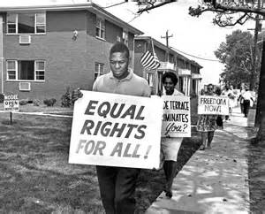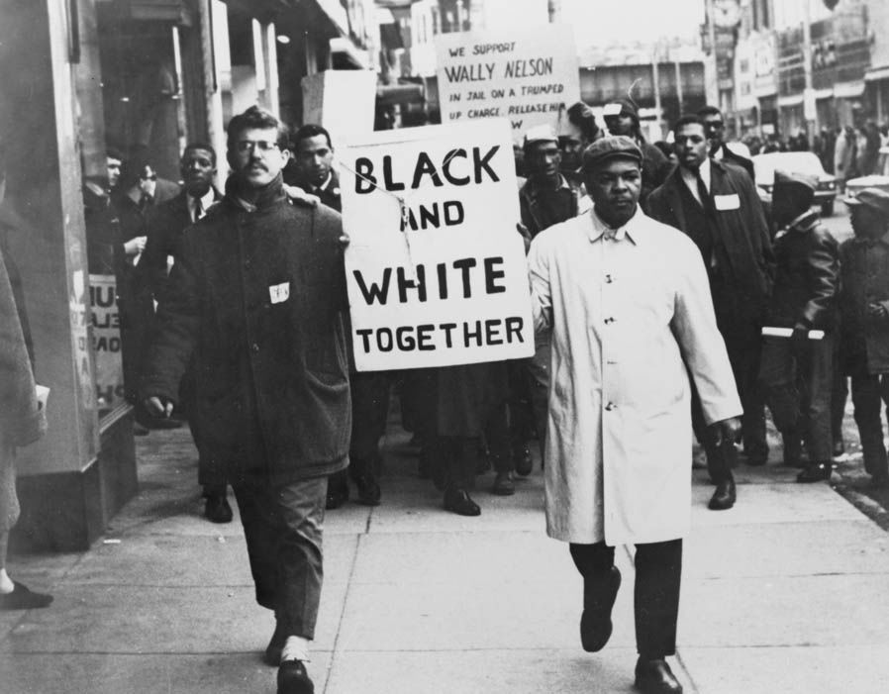
Background from A Raisin in the Sun : The playwright, Lorraine Hansberry, published the Raisin in 1959, and her writing was largely influenced by what was going on around her, specifically the lack of fair housing. Based on this, make a prediction of the plotline of A Raisin in the Sun. 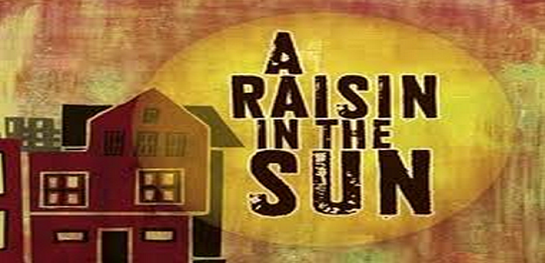
Non-Violent Resistance
- Participants resist or disobey laws that they do not agree with due to being unjust, unfair, or discriminatory.
- Often used as a means for change and to bring attention to a cause or movement.
- Allows for civil discussion and discourse without unleashing destruction and bloodshed.
- More likely to attract a large and diverse group of supporters than an armed or violent struggle.
- Mahatma Gandhi, leader of the Indian independence movement, used tactics of non-violent resistance in his efforts to gain independence from the British Empire.
- Dr. Martin Luther King, Jr. combatted racial discrimination and segregation in the United States through non-violent resistance to discriminatory laws and practices.
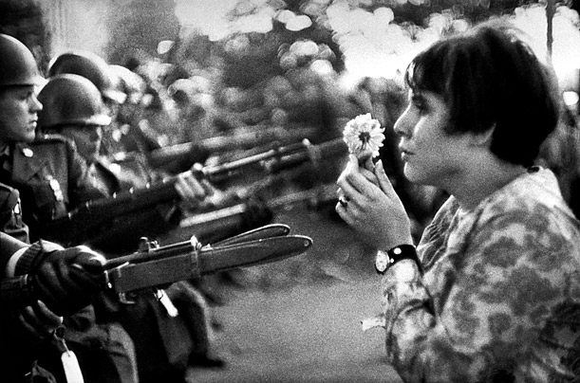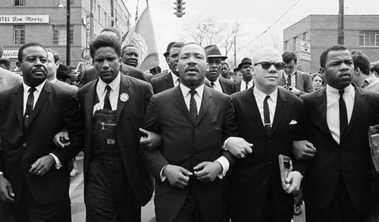
Mahatma Gandhi once said:
“There are many causes that I am prepared to die for, but no causes that I am prepared to kill for.”
Question: Do you agree or disagree with Gandhi’s statement and the idea of non-violent resistance? Explain.
Disenfranchisement
Disenfranchisement is the denial or prevention of a person or group of people from being able to vote.
- The 15th Amendment to the United State Constitution, ratified in 1870, allowed all men over the age of 21 to vote and prohibited voting denial based on “race, color, or previous condition of servitude.”
- Despite this amendment, many black and poor white citizens were either denied the right to vote or voting was made extremely difficult to the point of impossibility by:
  - Poll Taxes: Certain states required citizens to pay a “poll tax” in order to register to vote. This requirement negatively affected poor citizens.
  - Character Requirements: Several states invoked a “good character” clause that often dictated military service in order to be considered of “good character” and therefore able to vote. Problem was, many black men had not serve in the military due to being enslaved as young men.
  - Educational Requirements: Many states had “literacy” clauses that required that all men to be able to read and write in order to vote. The exception to this was a “grandfather clause” that said men could vote if their father or grandfather had voted prior to 1867. Obviously, this clause only applied to white men who couldn’t read or write, as no black men would have been able to vote prior to 1870.
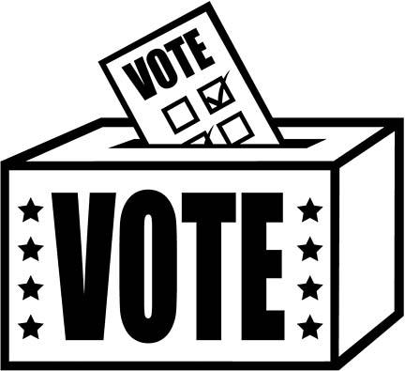Question: A Raisin in the Sun makes a statement about gender discrimination, as much as it does about racial discrimination. Though women could not vote until 1920, how might poll taxes, character requirements, and literacy tests have affected women if they HAD been able to vote at the time?
Jim Crow Laws
- The phrase “Jim Crow” has been attributed to “Jump Jim Crow” which was a song and dance performance of a man imitating a physically disabled slave. This was performed by a white actor in blackface.
- Jim Crow Laws were state and local laws enforcing racial segregation in the United States, particularly in the South, and mandated a “separate, but equal” status for African Americans.
- Despite the requirement for facilities to be “equal,” facilities for African-Americans were almost always lesser quality and underfunded.
- Segregation of facilities included public places, restrooms, drinking fountains, public transportation, the military, federal workplaces, and public schools.
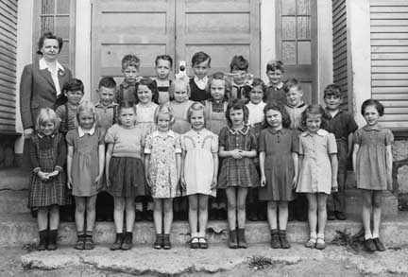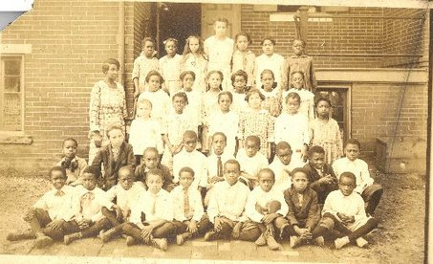
Question: Think about the people who you attend school with. How would Jim Crow Laws affect Crowley ISD and how might your own education – both academic and social – be different if Jim Crow Laws were still around?
Dr. Martin Luther King, Jr.
- Martin Luther King, Jr. was an American Baptist minister who was a leader in the Civil Rights movement.
- He studied theology at Boston University where he received his Ph.D.
- Co-founded the Southern Christian Leadership Conference or SCLC whose main goal upon creation was to coordinate and support non-violent action as a method of desegregating bus systems across the South.
- Dr. King and the SCLC used non-violent tactics such as sit-ins and openly violating discriminatory laws in order to provoke large-scale arrests and open the door to negotiating fair and just laws for all people.
- Dr. King encouraged and practiced non-violent methods of creating change, even when he was violently attacked (stabbed with a letter opener, hit in the head by a thrown brick, bomb threats, etc…).
- He led and helped organize the March on Washington in 1963 which was one of the largest political rallies for human rights in United States history. More than 250,000 people attended. At the rally, Dr. King delivered his “I Have a Dream” speech that called for civil rights laws, desegregation of public schools, a fair minimum wage, and job training for the unemployed.
- Over time, Dr. King was arrested approximately 30 times for civil disobedience of laws.
- Dr. King was assassinated in 1968 after being shot as he stood on the balcony of his hotel room.
- In 1983, President Reagan signed a bill creating a federal holiday to honor Dr. King’s accomplishments and his memory.
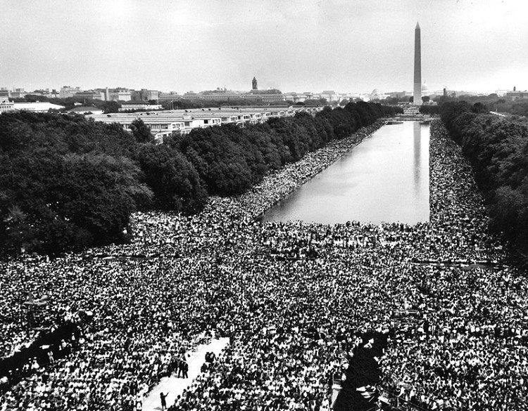

Question: Have you ever seen Dr. King’s “I Have a Dream” speech in its entirety? If so, what was your impression? If not, what do you know about it?

Montgomery Bus Boycott
- The Montgomery Bus System used a specific system of segregation:
  - The first ten rows were always reserved for white passengers.
  - The back ten rows were supposed to be reserved for black passengers.
  - The middle section consisted of unreserved seats that white and black passengers could use on a segregated basis (no white and black passengers could sit next to each other on a row).
- The Montgomery Bus Boycott was one of the most defining events that began the Civil Rights Movement.
- Prior to boycotting the use of public transportation, mostly buses, in Montgomery, Alabama, many people participated in non-violent resistance acts regarding segregation on public transportation.
- In 1944, baseball player Jackie Robinson refused to move to the back of the military bus when stationed at Fort Hood during his military service. Robinson was arrested by military police who recommended that he be court-martialed (on trial by the military). His commanding officer refused and Robinson was let go.
- In 1955, Claudette Colvin, a 15-year-old student at Booker T. Washington High School in Montgomery, Alabama, was arrested and forcibly removed from the bus when she refused to give up her seat to a white man.
- In 1955, Rosa Parks boarded a Montgomery bus after work and sat in the first row of the “colored section.” As more people continued to board the bus, all of the seats filled up and several white men were standing. The bus driver moved the sign for the “colored section” back one row and told Parks and three other people to move. Parks refused to move, was arrested, and charged with a law violation, even though she was technically in the “colored section” the whole time.
- Tired of this unfair treatment, black citizens of Montgomery refused to ride the bus (therefore hurting the bus system financially) until they were treated fairly and with courtesy and black drivers were given the same employment opportunities on the bus system.
- The boycott lasted for 381 days, by which time the Montgomery bus system was financially struggling and the city repealed the segregation law.
NAACP
- The National Association for the Advancement of Colored People, or NAACP, is an African-American civil rights organization that was formed in 1909.

- The mission of the NAACP was to “promote equality of rights and to eradicate caste or race prejudice among the citizens of the United States; to advance the interests of colored citizens; to secure them from partial suffrage; and to increase their opportunities for securing justice in the courts, education for the children, employment according to their ability, and complete equality before law.”

Use the definitions below to aid in your understanding of the NAACP’s mission, then put the mission into your own words.
- Eradicate: destroy completely; put an end to
- Caste: a group of people who are social distinct
- Prejudice: Prejudgment, usually negative, based on gender, race, age, disability, etc…
- Partial: incomplete or limited
- Suffrage: the right to vote in political elections

Lorraine Hansberry
- Lorraine Hansberry was an African-American playwright and writer.
- She was the first black woman to write a play that was performed on Broadway.
- Hansberry was passionate about equal rights for all people regardless of race, gender, sexuality, or religion.
- When she was young, her father purchased the family a house in the Washington Park subdivision of Chicago – a predominately white neighborhood. Their neighbors protested the Hansberry family living in the neighborhood and sued to have them removed.
- Despite marrying a man in 1953, it is widely believed that Hansberry was a closeted lesbian.
- Hansberry struggled with the idea of organized religion and considered herself to be an atheist.
- She died in 1965 at the age of 34 due to pancreatic cancer.

The following are characters from the play A Raisin in the Sun:
- Walter Lee Younger: protagonist; male; early 30s; chauffer

- Beneatha Younger: Walter’s sister; female; early 20s; medical school student

- Lena Younger: Walter and Beneatha’s mother; female; 60s

- Ruth Younger: Walter’s wife; female; early 30s

- Travis Younger: Walter and Ruth’s son; 7ish; grade school student

Question: Hansberry wrote A Raisin in the Sun using her own background and personality for one of the characters. Which character above do you think will be the most similar to Lorraine Hansberry? Explain your response.

