Imagery and Tone with “Strange Fruit”

Identifying literary devices and analyzing why an author chooses to say it THAT way is very important. Connecting the method (imagery and tone) to the meaning helps to create a deeper understanding of the work.

Define
Imagery: ___________________________________________________________________
____________________________________________________________________________

Tone: ______________________________________________________________________
____________________________________________________________________________

QUOTE | SENSE | What image is created?
 |  | Through the imagery of…I can feel…
 | 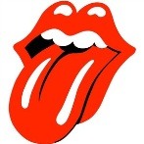 | Through the imagery of…I can taste…
 | 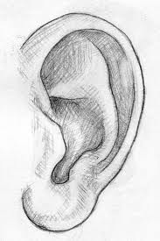
How does the imagery affect the tone of the piece?

The imagery used to describe___________________________________conveys a tone of

___________________________________________.

In what ways is the imagery used ironic? __________________________________________________________________________________________________________________________________________________________________________________________________________________________________________

Why is imagery important in writing? __________________________________________

_________________________________________________________________________

