1. Are Jews a Race?
- Jews are not a race. Race is a genetic distinction, and refers to people with shared ancestry and shared genetic traits. You can't change your race; it's in your DNA.
- Common ancestry is not required to be a Jew, one can simply convert to be a Jew.
- In the 1980s, the United States Supreme Court ruled that Jews are a race for purposes of certain anti-discrimination laws.
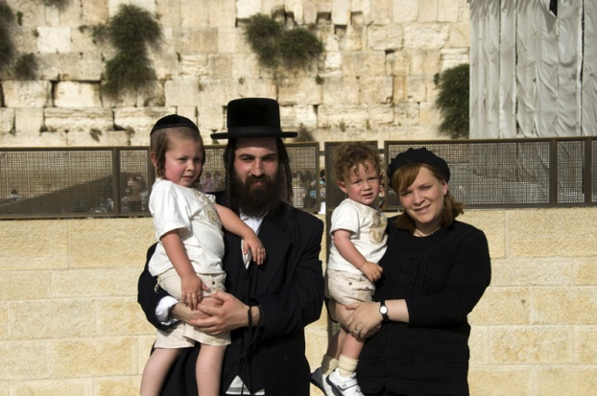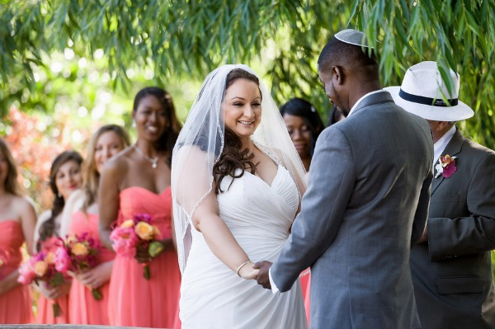
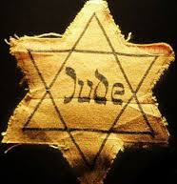
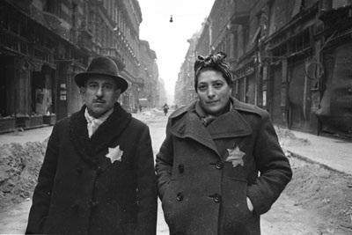
From Night : At the beginning of the book Night, the Jews in Elie’s hometown are forced to wear a star on their clothing in order to identify themselves as Jews.

Question:
What does the Jewish star symbolize? (Think: If a word could replace the star on Jews’ clothing, what would that word be?)
2. Genocide
Any of the following acts committed with intent to destroy, in whole or in part, a national, ethnical, racial or religious group is known as genocide:
- Killing members of the group;
- Causing serious bodily or mental harm to members of the group;
- Deliberately inflicting on the group conditions of life calculated to bring about its physical destruction in whole or in part;
- Imposing measures intended to prevent births within the group;
- Forcibly transferring children of the group to another group.
- The term “genocide” did not exist prior to 1944. It is a very specific term, referring to violent crimes committed against a group with the intent to destroy the existence of the group. Human rights, as laid out in the US Bill of Rights or the 1948 United Nations Universal Declaration of Human Rights, concern the rights of individuals.
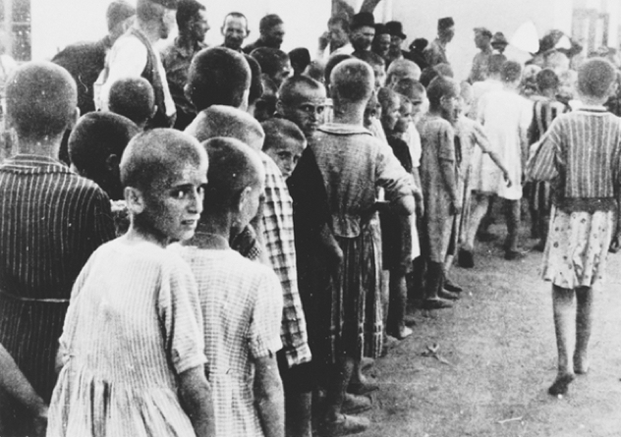
- geno-, from the Greek word for race or tribe, with -cide, from the Latin word for killing
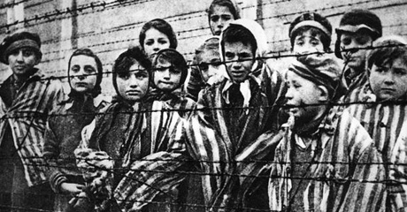
Questions:
1. What are the denotative and connotative definitions of genocide?
2. Do you defend (agree), challenge (disagree), or qualify (a little bit of both) Elie Wiesel’s quote, “Human suffering anywhere concerns men and women everywhere”?

3. Who is a Jew?
According to Jewish law, a child born to a Jewish mother or an adult who has converted to Judaism is considered a Jew.
- Jews come in all shapes, sizes, ethnicities, and nationalities. There are black Jews from Ethiopia, Chinese Jews from Shanghai, Jews from Morocco, South America, and several other locations.
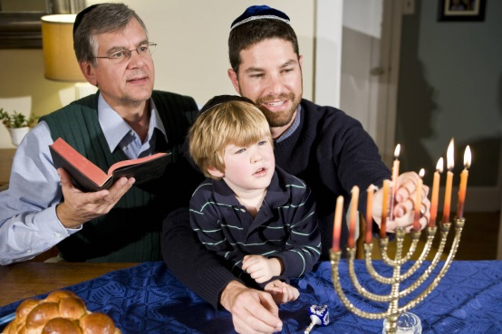
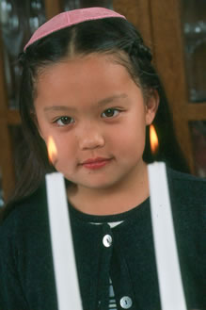
- Approximately 13.75 million people worldwide identify as Jewish, with the vast majority living in either the United States or Israel.

- Many times, stories help create identity.

- Our identity is a combination of many factors. It includes both the labels, words, and phrases we use to describe ourselves. Gender, ethnicity, religion, occupation, and physical characteristics are all part of one’s identity.

Question:
How would you describe your identity? Write at least 3 sentences.
4. What Do Jews Believe?
Judaism focuses on relationships: the relationship between God and mankind, between God and the Jewish people, between the Jewish people and the land of Israel, and between human beings. Jewish scriptures tell the story of the development of these relationships.
Jews believe (a basic list):
- God exists and He is unique and eternal.
- The Messiah will come and the dead will be resurrected
- God knows the thoughts and deeds of humanity.
- The Torah, first 5 books of the Bible, and the Talmud, was given to Moses.
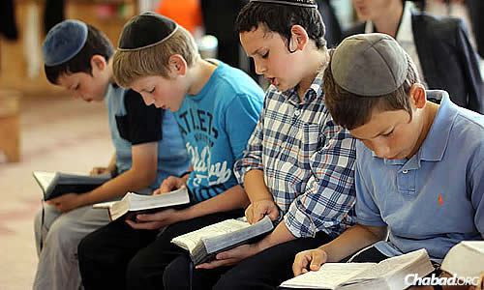
Question:
If an author with Jewish background wrote an article about religion, what do you think the author’s tone in the article would be?
Use this sentence starter for help: The author’s tone in the article could be best described as… because …
5. Torah and Talmud
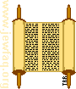
"Torah" refers to the Five Books of Moses: Genesis, Exodus, Leviticus, Numbers and Deuteronomy. But the word "torah" can also be used to refer to the entire Jewish bible (the body of scripture known to non-Jews as the Old Testament and to Jews as the Tanakh or Written Torah.

Torah Scrolls
The scriptures that Jews use in services are written on parchment scrolls. They are always hand-written, in attractive Hebrew calligraphy.
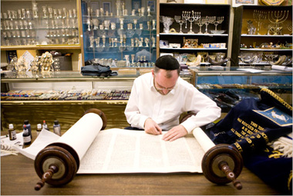
You are not supposed to touch the parchment on these scrolls; some say because they are too holy; some say because the parchment, made from animal skins, is a source of ritual defilement; others say because your fingers' sweat has acids that will damage the parchment over time.
Instead, you follow the text with a pointer, called a Yad. "Yad" means "hand" in Hebrew, and the pointer usually is in the shape of a hand with a pointing index finger.
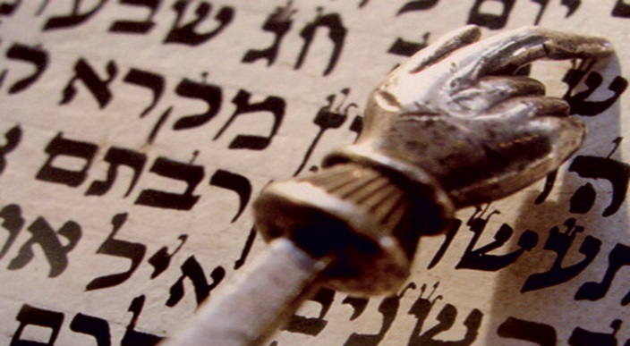

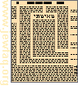
The Talmud
Talmud (tahl muhd) a 45-volume collection of scriptural interpretation, commentary, and traditions, edited in 500 A.D. and used as a source book of Jewish wisdom to solve problems and settle disputes.
The Talmud is one of the most challenging religious texts in the world!
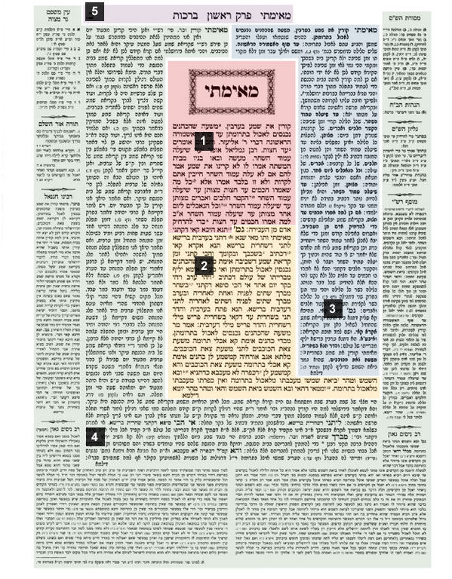
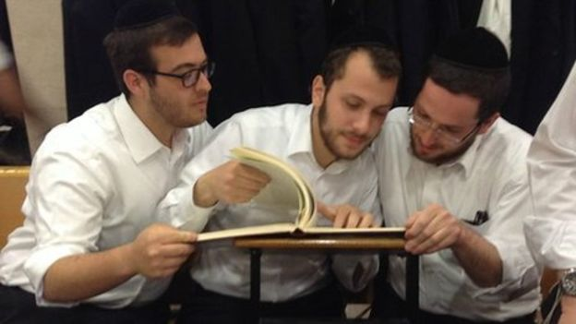

Question:
1. In the “Torah Scrolls” section, what was the purpose for taking this photograph?
2. How do the photographs in the “Talmud” section help the reader (aka: YOU) better understand characteristics of the Talmud?
6. Jewish Mysticism, Kabbalah, and the Zohar
Mysticism: a religious practice based on the belief that knowledge of spiritual truth can be gained by praying or thinking deeply
- Mysticism was taught only to those who had already learned Torah and Talmud.
- Mysticism and mystical experiences have been a part of Judaism since the earliest days. The Torah contains many stories of mystical experiences, from visitations by angels to prophetic dreams and visions.
- We also have a mystical tradition, known as Kabbalah. The primary written work in the Kabbalistic tradition is the Zohar, which was written in the middle ages.
- Traditionally, rabbis discouraged teaching this material to anyone under the age of 40, because it is too likely to be misinterpreted by anyone without sufficient grounding in the basics.

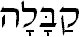

Question:
Explain the relationship between Mysticism, Kabbalah, and the Zohar.

7. Rabbi
- There are a number of different people who serve special roles in the Jewish community.
- Rabbi is simply a teacher, a person sufficiently educated in (Jewish law) and tradition to instruct the community and to answer questions and resolve disputes regarding the law.

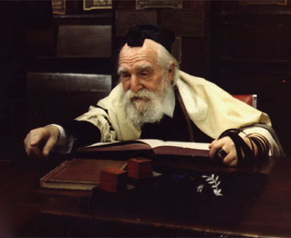
Question:
Harsh and difficult circumstances often make people lose hope and become discouraged. Who do you consider to be a “Rabbi” in your life?

8.The Land of Israel
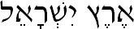
• Israel is the land promised to Abraham in the Bible
• Israel is central to the Jewish religion
• Zionism is a political movement to establish a Jewish homeland
• Israel is a democratic country
• Israel is home to more than 1/3 of the world's Jews
• 20% of Israel's citizens are not Jewish
Jews were exiled from the land of Israel by the Romans in 135 C.E., after they defeated the Jews in a three-year war, and Jews did not have any control over the land again until 1948 C.E.
The Holocaust brought the need for a Jewish homeland into sharp focus for both Jews and for the rest of the world. The Jews who tried to flee Nazi Germany were often turned back due to immigration limitations at the borders of every country, including the United States, Britain and Palestine. Many of those who were sent back to Germany ended up in death camps where they were systematically murdered.
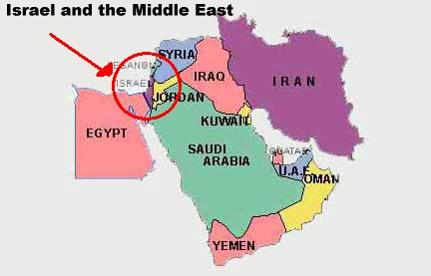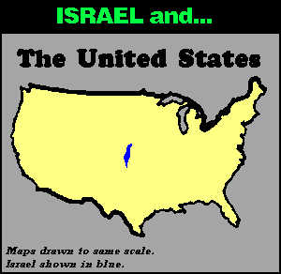
Question:
Create two high-level questions, based off of the above information. Note: Questions must require deep thinking!
9. Anti-Semitism
Anti-Semitism is the prejudice, discrimination and hatred of Jews as a national, ethnic, religious or racial group.
Anti-Semitic sign reading, "Juden sind hier unerwunscht" (Jews Are Unwanted Here).
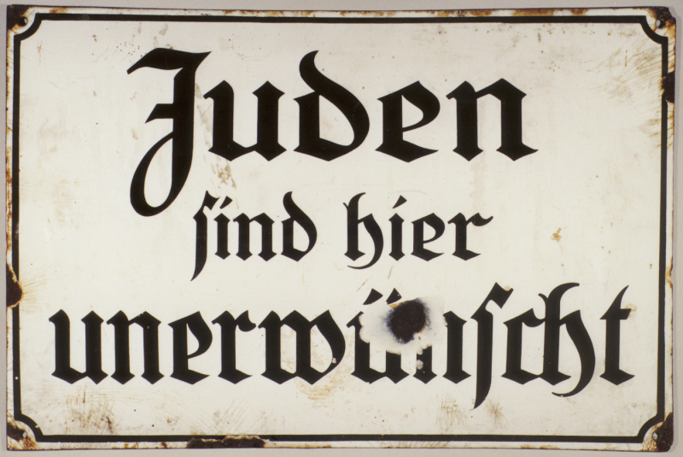
From Night, a memoir of the Holocaust: "The Jews of Budapest live in an atmosphere of fear and terror. Anti-Semitic acts take place every day, in the streets, on the trains. The Fascists attack Jewish stores, synagogues. The situation is becoming very serious …"
Question:
How is this sign similar to the early 1900s in American history?
10. Ghettos
During the Holocaust, ghettos were a central step in the Nazi process of control, dehumanization, and mass murder of the Jews.
- Ghettos were set up to segregate Jews from the rest of the population.
- They were designed to be temporary; some lasted only a few days or weeks, others for several years.
- The vast majority of ghetto inhabitants died from disease or starvation, were shot, or were deported to killing centers
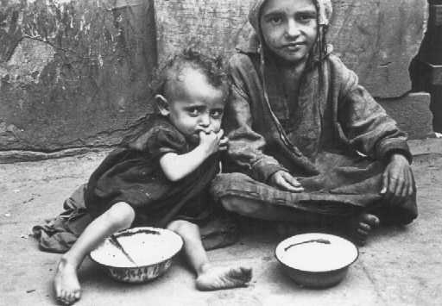
Children eating in the ghetto streets. Warsaw, Poland, between 1940 and 1943.— US Holocaust Memorial Museum
Questions:
1. Describe the effect of segregating “Jews from the rest of the population”. (Hint: “effect” means “change”)
2. Explain the similarities between Jewish ghettoes and conditions in Europe during the 1600s (Think: the Bubonic Plague), and modern ghettoes.
11. Spanish Inquisition
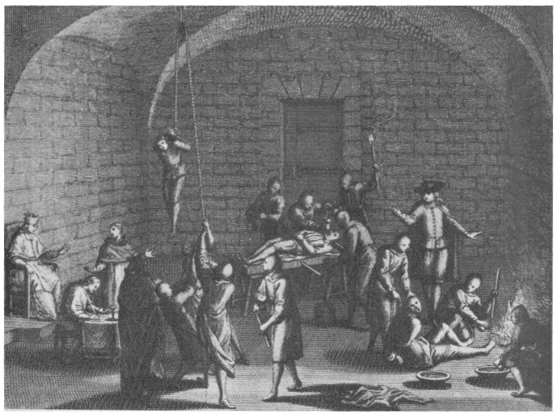
Founded in 1478 by Ferdinand V and Isabella, under Father Tomás de Torquemada, the Spanish Inquisition began torturing "new Christians". New Christians were Jews who had recently converted to Christianity; however, the Inquisition suspected these new Christians of having lapsed back into an observance of Judaism, in order to eradicate blasphemy, immorality, and homosexuality. Some suspects were strangled or burned at the stake in public ceremonies; others fled to Turkey. The church enriched itself by confiscating their property.
From Night: “Here came the Rabbi…His mere presence among the deportees added a touch of unreality to the scene. It was like page torn from some storybook, from some historical novel about the captivity of Babylon or the Spanish Inquisition.”

Question:
What was the author’s purpose in Night for using figurative language to describe the presence of the Rabbi?

The Holocaust

12. Holocaust
- The Holocaust was the systematic and state-sponsored persecution and murder of six million Jews by the Nazi regime and its collaborators.
- The Nazis, who came to power in Germany in January 1933, believed that Germans were "racially superior" and that the Jews, deemed "inferior," were an alien threat to the so-called German racial community.
During the era of the Holocaust, German authorities also targeted other groups because of their perceived "racial inferiority": Roma (Gypsies), the disabled, and some of the Slavic peoples (Poles, Russians, and others). Other groups were persecuted on political, ideological, and behavioral grounds, among them Communists, Socialists, Jehovah's Witnesses, and homosexuals.
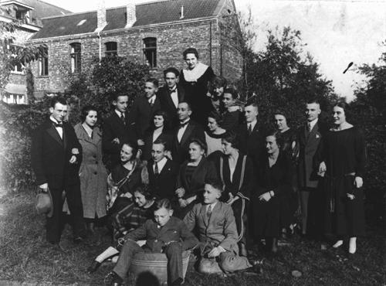
Two German Jewish families at a gathering before the war. Only two people in this group survived the Holocaust. Germany, 1928.— US Holocaust Memorial Museum
From Night : “Never shall I forget these things, even if I am condemned to live as long as God Himself. Never.”
Question:
What was the author’s purpose for writing and publishing Night, a personal account of his experiences in the Holocaust?

13. Killing Centers
- In German-occupied Europe during World War II, the killing center was a place established for mass murder of human beings.
- Several countries contained a mixture of killing centers and concentration camps.
- Unlike concentration camps, which served primarily as detention and labor centers, killing centers (also referred to as "extermination camps" or "death camps") were almost exclusively "death factories." German SS and police murdered nearly 2,700,000 Jews in the killing centers either by asphyxiation with poison gas or by shooting.
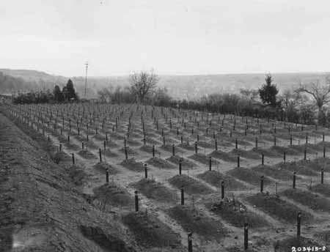
Question:
Infer why Nazis would need to have killing centers, rather than just have only concentration camps.
14. Concentration Camps
Concentration camps served primarily as detention and labor centers, as well as sites for the murder of smaller, targeted groups of individuals. Jews would travel for days on cattle cars to arrive at concentration camps. Concentration camps contained a bigger percentage of men than women.
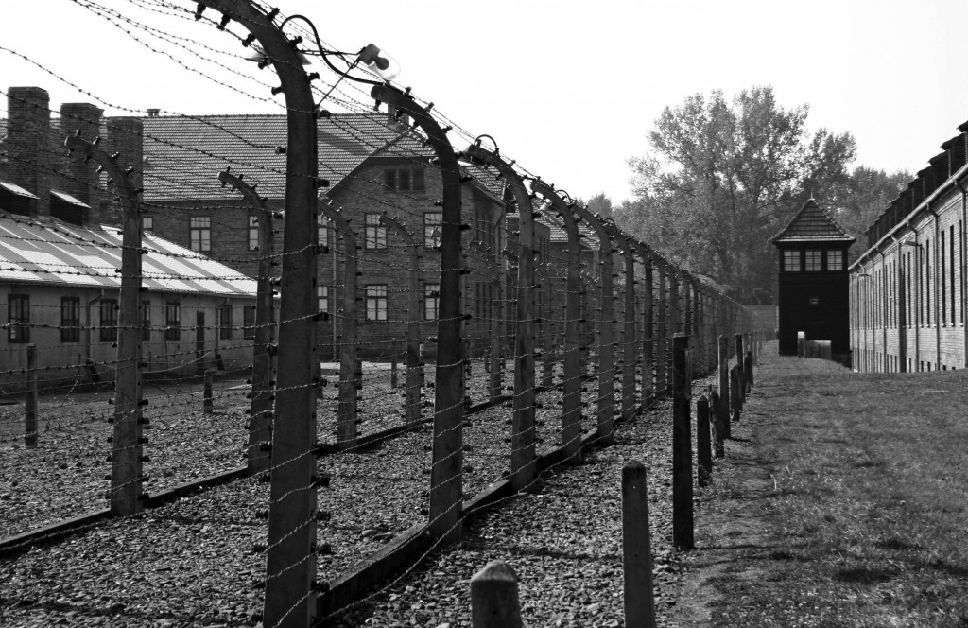
From Night: “We can’t go like beasts to the slaughter.”

Question:
Describe the mood in the above use of figurative language.

15. AUSCHWITZ-BIRKENAU
- The largest killing center was Auschwitz-Birkenau, which by spring 1943 had four gas chambers (using Zyklon B poison gas) in operation.
- Almost all of the people who arrived at the camps were sent immediately to death in the gas chambers (with the exception of very small numbers chosen for special work teams known as Sonderkommandos).
- At the height of the deportations, up to 6,000 Jews were gassed each day at Auschwitz-Birkenau in Poland.
- Over a million Jews and tens of thousands of Roma, Poles, and Soviet prisoners of war were killed there by November 1944.
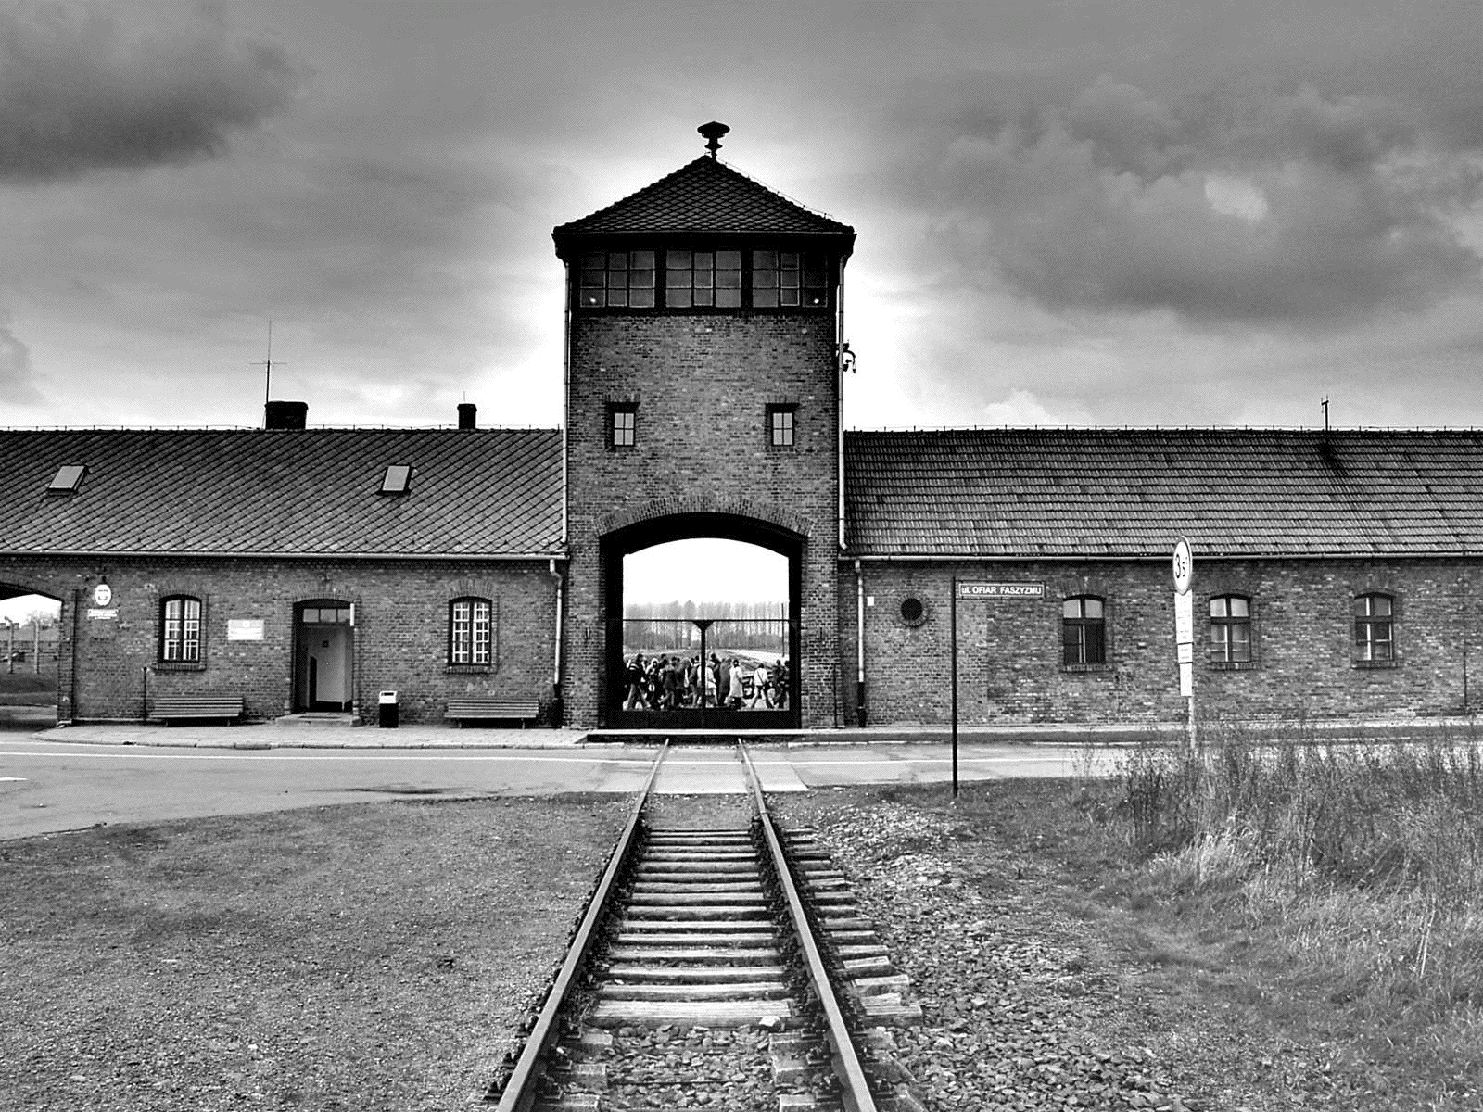
Question:
What do you think the mindset was of Jews who were chosen to be a part of Sonderkommandos? How do you think Sonderkommando Jews interacted with other Jews?

16. SS Soldiers
- The SS (Schutzstaffel; Protection Squadrons), were soldiers who perceived themselves as the “racial elite” of Nazi soldiers.
- Founded in 1925, the “Schutzstaffel,” German for “Protective Echelon,” initially served as Nazi Party leader Adolf Hitler’s (1889-1945) personal bodyguards, and later became one of the most powerful and feared organizations in all of Nazi Germany.
- The SS had more than 250,000 members and multiple subdivisions, engaged in activities ranging from intelligence operations to running Nazi concentration camps.
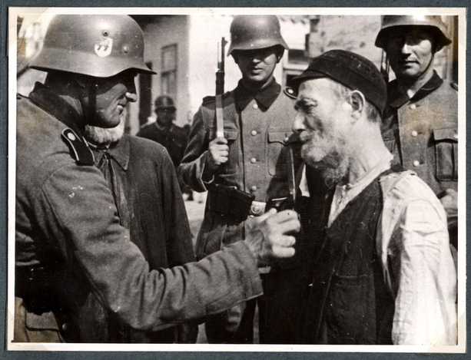
Poland, SS soldiers subjecting an elderly Jewish man to humiliation

- There are several types of conflict. Some of Man vs. Animal, Man vs. Nature, Man vs. Society, and Man vs. himself.
Question:
“Behind me, and old man fell to the ground. Near him was an SS man, putting his revolver back into its holster.”

1. Which kind of conflict is shown in this quote?
2. In your opinion, which type of conflict is the most dangerous?

17. Nazi
Nazi: a member of the National Socialist German Workers' Party, which controlled Germany from 1933 to 1945 under Adolf Hitler and advocated totalitarian government, territorial expansion, anti-Semitism, and Aryan supremacy, all these leading directly to World War II and the Holocaust.
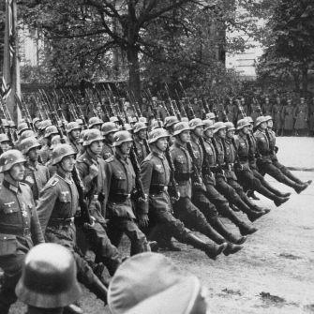
Questions:
1. Imagine and describe an encounter between a Nazi and a Jew. You must write at least 3 sentences.
2. What was the photographer’s purpose for taking this photo?

18. Adolf Hitler
Born in Austria in 1889, Adolf Hitler rose to power in German politics as leader of the National Socialist German Workers Party, also known as the Nazi Party. Hitler ran for German President, but was defeated by Paul von Hindenburg; however, in 1933, Hindenburg appointed Hitler as chancellor of Germany. After Hindenburg’s death in 1934, Hitler declared himself Furher, and Germany fell under tyrannical rule. His policies caused World War II and the Holocaust. Hitler’s hatred of those deemed “unpure” caused millions of people to die in the Holocaust. Hitler committed suicide with wife Eva Braun on April 30, 1945, in his Berlin bunker.
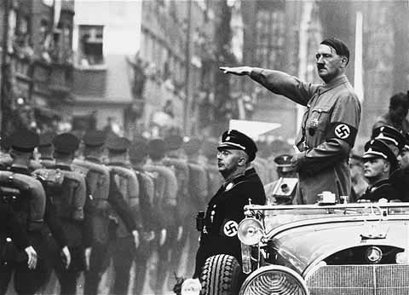
Question:
1. What context clues help the reader understand the meaning of Furher?
2. Infer what major changes Germany went through during the shift between Hindenburg as President and Hitler as Furher.
19. Gestapo
Gestapo (gee stahp oh) the Geheime Staatspolizei, or secret state police, an arm of the Schutzstaffel, called the SS or Black Shirts, were a hand-picked corps of 50,000 secret police who functioned as security officers and as Hitler's body guard. Gestapo were involved in many aspects of the Holocaust, and they became the most hated and feared of German terrorists.
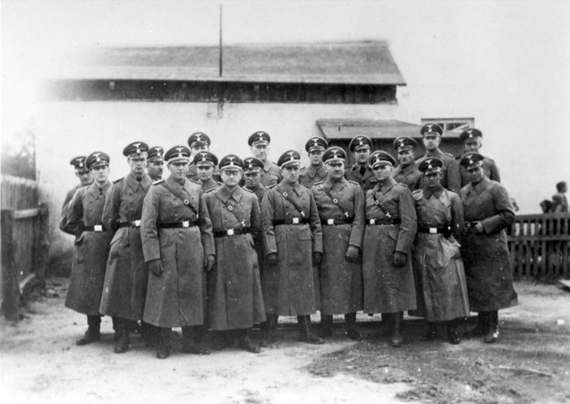
Question:
1. How are the Gestapos similar to modern terrorists?
2. Infer why many “hated and feared” the Gestapo.
20. Fascists
Fascist Party: a political party supporting brutally oppressive, dictatorial control of public speech and civil rights and enforcing uncompromising adherence to inhumane laws. There were German Fascists under Hitler and Italian Fascists under Mussolini.
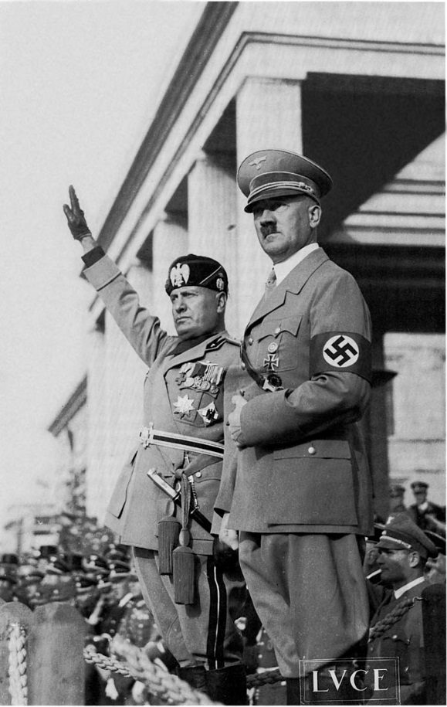
Adolf Hitler and Benito Mussolini in Italy.
From Night: "The Jews of Budapest live in an atmosphere of fear and terror. Anti-Semitic acts take place every day, in the streets, on the trains. The Fascists attack Jewish stores and synagogues. The situation is becoming very serious …"
Question:
Why do political parties and governments commit evil acts toward humans who are different than themselves?

21. Synagogue
• A Jewish "church" is called a synagogue, shul or temple
• A synagogue is a place of worship and study, and a "town hall"
• Synagogues are run by laypeople and financed by membership dues
• There are several important ritual items found in the synagogue
• Non-Jews may visit a synagogue, but should dress and behave appropriately
• The Temple is the ancient center of Jewish worship where sacrifices were performed
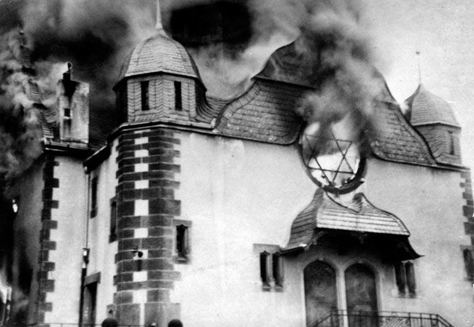
Question:
Infer the Nazi’s purpose for destroying Jewish homes and synagogues. You must respond in at least two sentences.
22. The Yellow Star
In November 1939, one year after Kristallnacht, the Nazi government followed the recommendation of leader Reinhard Heydrich and first introduced mandatory ID badges for Jews in Poland. It was announced that "severe punishment is in store for Jews who do not wear the yellow badge on back and front."

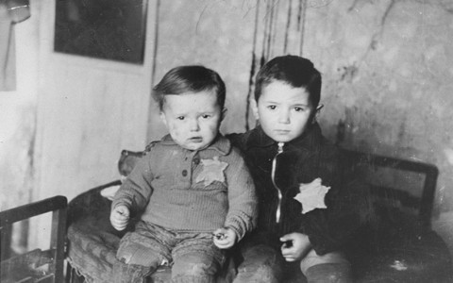

From Night:
- A character said to the narrator, "The yellow star? Oh well, what of it? You don't die of it."
- Dramatic irony is when the reader knows more information than the character does.
Question:
Given what you know about the importance of the yellow star in the Holocaust, why is the above quote an example of dramatic irony?
23. Shabbat
- Shabbat is primarily a joyful day of rest and spiritual enrichment. The word "Shabbat" comes from the root Shin-Beit-Tav, meaning to cease, to end, or to rest.
- Shabbat is the most important ritual observance in Judaism. It is the only ritual observance instituted in the Ten Commandments.
- Shabbat is two commandments: to remember and to observe
- At the beginning of Shabbat, candles are lit by the woman of the household. They are lit before Shabbat begins, at least 18 minutes before sunset. She lights two candles, passes her hands over the candles a few times, then covers her eyes and recites this blessing. After the blessing is complete, she uncovers her eyes and looks at the lit candles as if for the first time.
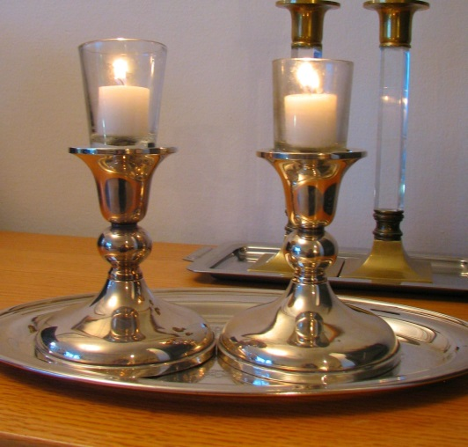
From Night: “Yet we practiced religion in a death camp. I said my prayers every day. On Saturday I hummed Shabbat songs at work. I was determined to remain a Jew even in the accursed kingdom.”
Question:
Infer why the Jewish people practiced their religion while being imprisoned in the death camp. Write at least two sentences.
24. Hasidic
Hasidic (ha sih dihk) an eighteenth-century group of Jews who stressed the joyous, ecstatic, elements in their faith.
The term also describes fiercely orthodox Jews who bind themselves to strict observance of Jewish laws.
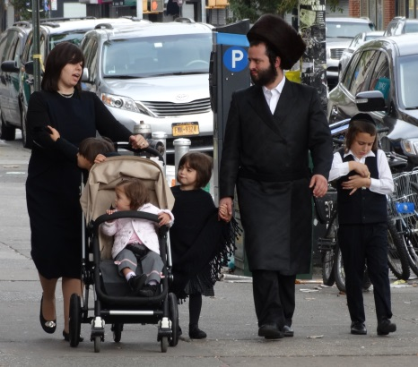
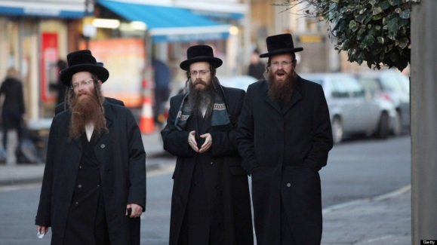
Everything Hasidic Jews wear has some kind of historical symbolism, special meaning, or is rooted in traditional and biblical reasons.

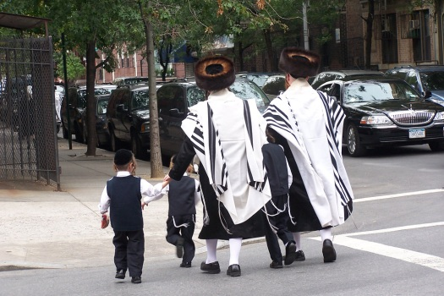

Question:
What kinds of clothing items shape your identity, and what do your clothing items symbolize? Write at least 5 sentences.

25. Jewish Signs and Symbols
Menorah: One of the oldest symbols of the Jewish faith is the menorah,seven-branched candelabrum used in the temple. 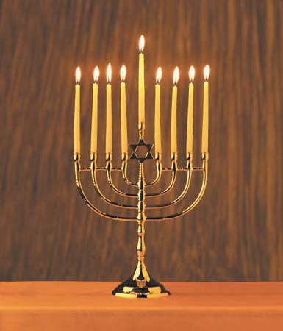
Yarmulke: The most commonly known and recognized piece of Jewish garb is actually the one with the least religious significance.
- It is an ancient practice for Jews to cover their heads during prayer.
- Whatever the reason given, however, covering the head has always been regarded more as a custom rather than a commandment.
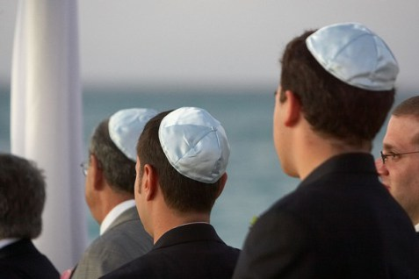
Magen David: The Magen David (Shield of David, or as it is more commonly known, the Star of David) is the symbol most commonly associated with Judaism today, but it is actually a relatively new Jewish symbol.
- It is supposed to represent the shape of King David's shield (or perhaps the emblem on it), but there is really no support for that claim in any early literature. 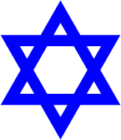
Question: What symbols represent your culture or religion?
26. Shekhinah in Exile
According to Kabbalah, God’s presence is called the Shekhinah.
In his account of the contents of Moishe’s chants, Wiesel reveals three things:
- God has been exiled by the actions of men;
- God suffers; and
- God’s return depends on humankind’s return from its own exile.
In other words, sin affects man and man’s relationship with God.
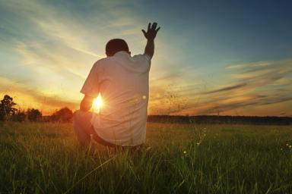
From Night: “He sang, or rather he chanted, and the few snatches I caught here and there spoke of divine suffering, of the Shekhinah in Exile, where, according to Kabbalah, it awaits its redemption linked to that of man.”
Question: Why do you think Elie writes about Moishe and Shekhinah on the first page of the entire story?
27. WWII
- It was the bloodiest, deadliest war the world had ever seen. More than 38 million people died, many of them innocent civilians. It also was the most destructive war in history. Fighting raged in many parts of the world. More than 50 nations took part in the war, which changed the world forever.

- For Americans, World War II had a clear-cut purpose. People knew why they were fighting: to defeat tyranny. Most of Europe had been conquered by Nazi Germany, which was under the iron grip of dictator Adolf Hitler. The war in Europe began with Germany's invasion of Poland in 1939. Wherever the Nazis went, they waged a campaign of terror, mainly against Jews, but also against other minorities.

- In Asia and the Pacific, Japanese armies invaded country after country, island after island. On December 7, 1941, Japanese planes bombed Pearl Harbor, Hawaii. The next day, the U.S. Congress declared war, taking the U.S. into World War II.

- Germany surrendered on May 7, 1945, ending the war in Europe. The war in the Pacific did not end until after the U.S. dropped two atomic bombs on Japan — the only time such bombs were ever used in war. Japan surrendered on August 14, 1945.
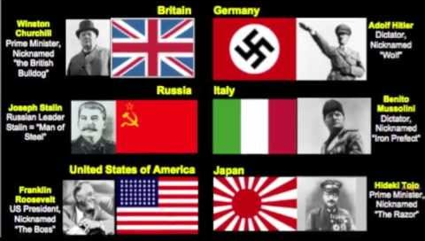

Question:
Do you defend, challenge, or qualify the United States’ decision to join a war for the purpose of “defeat[ing] tyranny” in various countries? You must write at least 3 sentences.
28. Deportations
The Nazi regime carried out their plans to destroy an entire people by deporting them to concentration or death camps. Jews were "deported"—transported by trains or trucks to six camps, all located in occupied Poland: Chelmno, Treblinka, Sobibor, Belzec, Auschwitz-Birkenau, and Majdanek-Lublin. The conditions on the train were horrible and animalistic, and these trains were packed with people. Trips to camps often took days.
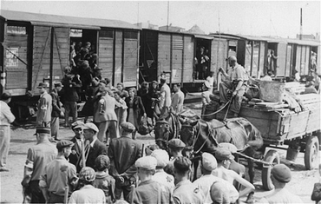From Night: “Lying down was not an option, nor could we all sit down. We decided to take turns sitting. There was little air. The lucky ones found themselves near a window; they could watch the blooming countryside flit by.”
Questions:
1. Why would the Nazis have such unfavorable conditions on the trains?
2. Based on the information above, infer what kind of issues and problems arised for the Jews while being deported to camps. Write down at least 3 issues.

29. Look/Sound familiar? – Budapest 2015
In Hungary, hundreds of migrants surrounded by armed police officers were tricked into boarding a train with promises of freedom, only to be taken to a “reception” camp. In the Czech Republic, the police hustled more than 200 migrants off a train and wrote identification numbers on their hands with indelible markers, stopping only when someone pointed out that this was more than a little like the tattoos the Nazis put on concentration camp inmates.
Razor-wire fences rise along national borders in Greece, Bulgaria, Hungary and France. Many political leaders stoke rising nationalism by portraying the migrants as dangerous outsiders whose foreign cultures and Muslim religion could overwhelm cherished traditional ways.
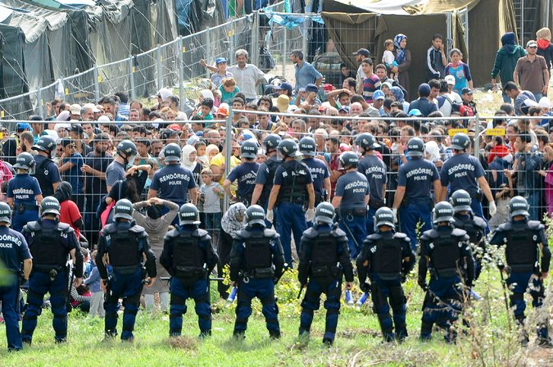

Syria - 2015
Syria has been in chaos since its outbreak in March 2011. The violence has cost the lives of more than 220,000 Syrians, displaced over half the population, and produced widespread atrocities and crimes against humanity.
The conflict is not simply a civil war between opposing armed forces. What started as a democratic uprising has now become an overtly sectarian conflict in which civilians are targeted for atrocities based upon their religious and ethnic identity. Members of Syria’s Sunni Muslim majority are bearing the brunt of the Syrian government’s massive campaign of crimes against humanity and war crimes, while some of the forces opposing the regime have committed abuses and atrocities against members of Syria’s religious and ethnic minorities.
The result of this conflict is a humanitarian catastrophe of staggering proportions. Every day Syrian men, women, and children are falling victim to the constant bombardment of their neighborhoods, schools, markets, and hospitals; to starvation, exposure, preventable diseases, and lack of medical care; and to torture, rape, and killings. The rapidly rising number of Syrian refugees now exceeds four million, and another 7.6 million are internally displaced.
As violence becomes more widespread and systematic, there is increasing danger that it could escalate to genocide. 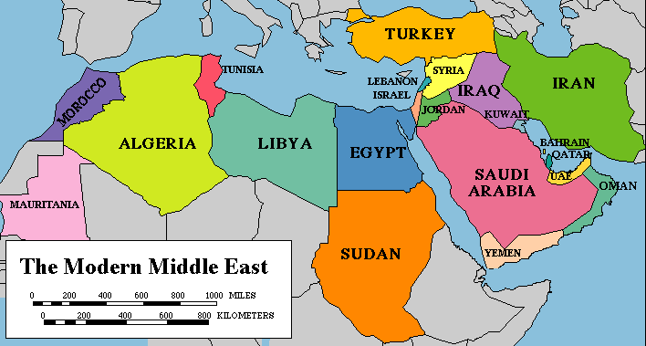
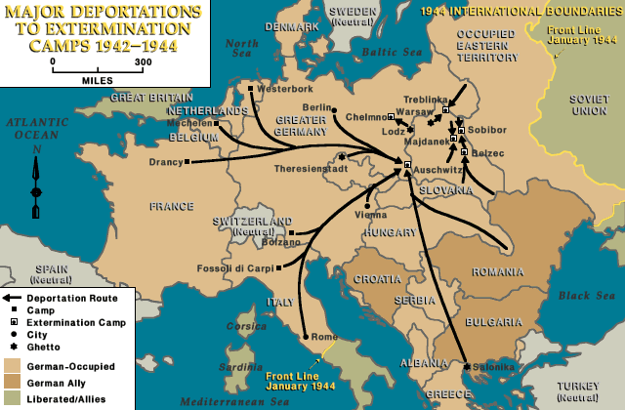
Questions:
1. Explain three similarities between the Jewish Holocaust and the conflict in Budapest and Syria.
2. Why is history beginning to repeat itself? Write at least two sentences.

